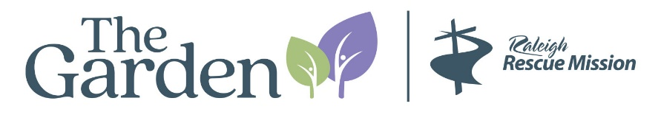
Department: Philanthropy/Development
Role: Development Coordinator
Reports to: VP of Development
Full time: 40 hours per week/ In-person

Mission Statement:
Believing every individual has sacred value, we equip people to impact the world for good through the love of Jesus Christ.

Summary of Position:
The Development Coordinator is responsible for the daily execution of specific tasks, duties or projects to help meet the needs of a growing Development program at Raleigh Rescue Mission. Reporting to the VP of Development, successful candidates will be able to perform defined organizational tasks on a regular basis, while also taking on unexpected tasks or projects that need to happen, often quickly. The person in this role should be an organized and proactive self-starter who is adept at using digital tools to streamline processes but also enjoys working with people, including donors, volunteers, community partners, staff and those served by Raleigh Rescue Mission.

Responsibilities:
- Develop and manage daily mail process including pick up from post office and appropriate distribution to both campuses
- Work closely with Senior Development Officer to assure that all receipts and acknowledgements are mailed in a timely manner
- Provide processing support for a multitude of projects including but not limited to donor stewardship letters, printed receipts, tribute cards, Christmas honor cards,
- Answer and respond to donor emails and phone calls in a timely manner
- Provide support to schedule donor meetings for CEO and VP of Development and assure that all details are managed including needed materials, location details, etc.
- Ongoing support for upkeep and improvement of the data hygiene of Salesforce including keeping records updated
- Manage office inventory including all collateral materials, copiers, and supplies
- Provide support for special events as needed, including managing rsvps when needed
- Works in partnership with Volunteer Manager to schedule in-person volunteers for mailings and projects
- Assumes cross-over responsibilities as needed in the absence of other staff
Qualifications:
College Degree Required with experience at a non-profit preferred
Knowledge and proficiency in Microsoft Office including word, excel, and powerpoint.
Technologically adept
Salesforce experience or other CRM experience preferred
Data entry efficiency and accuracy
Ability to manage multiple tasks in a fast paced environment
Ability to provide excellent customer service by positively interacting with donors, clients, and volunteers
Excellent attention to detail
Excellent organization and tracking skills
Accounting/financial background helpful
Flexibility is a must
High level of integrity and trust
Ability to organize a daily workload

Working environment:
Currently offices are located in downtown Raleigh but will be moving in summer, 2026 to Knightdale
Expected to be in the office daily
Hours are 8:30-5:30pm
Some functions occur after normal work hours and on weekends requiring staff to be present

